Felton

Viola

United Methodist

Church
Stockings for Soldiers
Once again our church participated in the Stockings for Soldiers Ministry, collecting a variety of hand-made, store bought items and money for shipping to military service people serving domestically and overseas.
This has been a very popular mission of our church in the last few years!
First Quarter
2019

Stockings for Soldiers has become a favorite project for our church! In the fall of each year we get information regarding the different items needed to fill the stockings as well as directions to make the actual stockings.
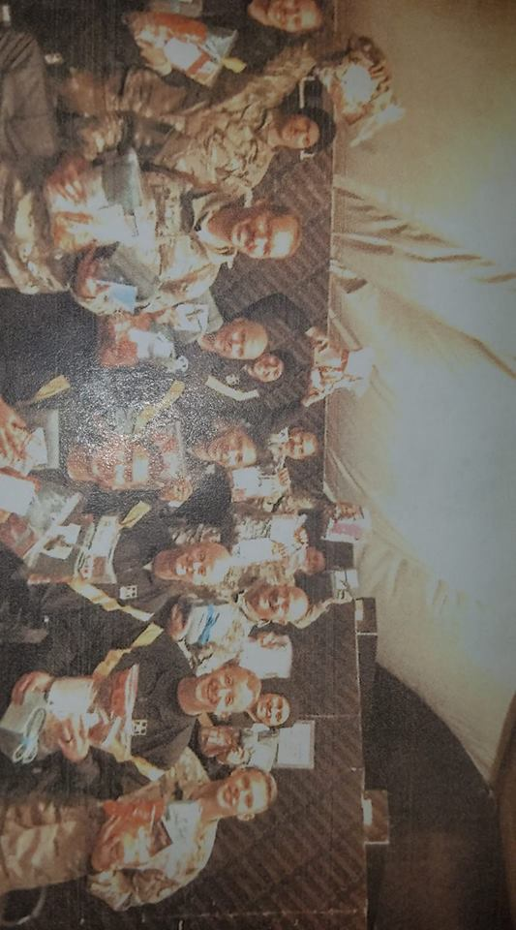
“On behalf of all our volunteers, I would like to thank you so very much for your generosity…” Judy Travis, Founder and Coordinator
This project has been in existence for 15 years and has sent over 100K personalized stockings filled with over 245 tons of goodies. We also donated $400 to help defray the thousands of dollars it takes to deliver the stockings. It must be done by regular mail so that they reach our soldiers by Christmas.

If the weather looks dicey please check our website, feltonviola.org, our Facebook page or WBOC for cancelation information!

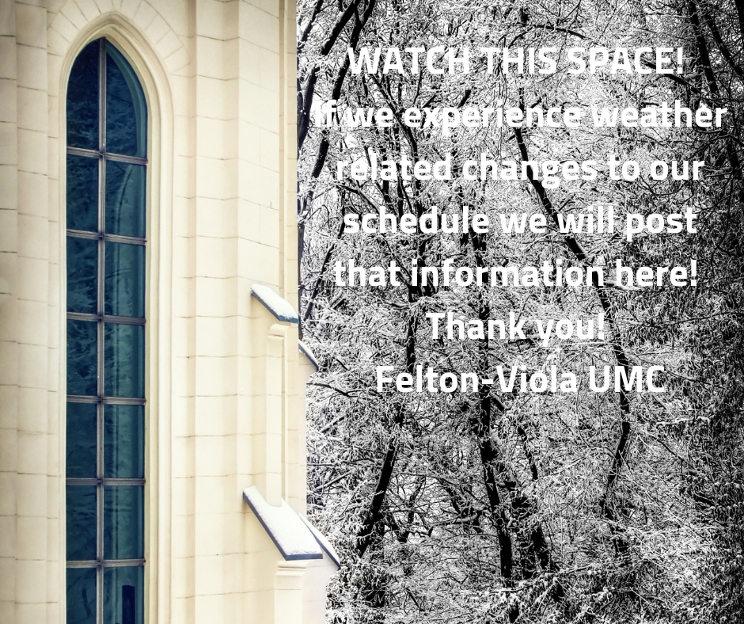

Upcoming Mission Projects
February is Lake Forest District Uniform collection. Each year in August we give away one new uniform shirt to each participating child. Last year we served 97 families and each family had multiple children. In the past we have done this collection later in the year but there are some yearly sales and coordinator Susie Shank wanted to be able to take advantage of them. Donations of money can be placed in the offering (PLEASE MARK THEM APPROPRIATELY) or if you find a sale the shirts must be any solid color with a collar and can have a small emblem.
March is our Camp Pecometh mission including clean up day! Jean Wothers is the coordinator so if you’d like to help check with her (302-284-9840). Cash donations (properly marked) are welcome too! We sponsor several special needs campers each summer as well as keeping our cabin in good repair and painted.

Commission on the Way forward
Our denomination is facing a challenge in the area of Human Sexuality in the very near future. None of us knows what the outcome will be.
We all need to be praying.
The Council of Bishops has called a Special Session of the General Conference of The United Methodist Church to be held February 23-26, 2019 in St. Louis, Missouri. The purpose will be to receive and act on a report from the Commission on a Way Forward based on the recommendations of the Council of Bishops.
The 32-member Commission was authorized by General Conference 2016 and appointed by the Council of Bishops to examine paragraphs in The Book of Discipline concerning human sexuality and exploring options to strengthen the unity of the church.

